# Bahria University,

## Karachi Campus



COURSE: SEL-448

SOFTWARE APPLICATION FOR MOBILE DEVICES

TERM: SPRING 2024, CLASS: BSE- 6(B)

Submitted By:

Muhammad Shoaib Akhter Qadri_____________79290___

(Name) (Reg. No.)

Submitted To:

Engr. Hamza / Engr. Adnan u Rahman

Signed Remarks: Score:__

INDEX

|  |  |  |  |  |
| --- | --- | --- | --- | --- |
| SNO | DATE | LAB NO | LAB OBJECTIVE | SIGN |
| 01 | 16/02 | 01 | Introduction to Android Studio |  |
| **02** | **23/02** | **02** | Introduction to AVD and ADB |  |
|  |  |  |  |  |
|  |  |  |  |  |
|  |  |  |  |  |
|  |  |  |  |  |
|  |  |  |  |  |
|  |  |  |  |  |
|  |  |  |  |  |
|  |  |  |  |  |
|  |  |  |  |  |
|  |  |  |  |  |

# Bahria University,

## Karachi Campus



LAB EXPERIMENT NO.

**_02_**

LIST OF TASKS

|  |  |
| --- | --- |
| **TASK NO** | **OBJECTIVE** |
| 01 | Setup AVD in your Device and Attach Screenshot in the file. |
| 02 | Install the Birthday Card Application in your Mobile devices using Android Debug Bridge. |
|  |  |
|  |  |
|  |  |
|  |  |
|  |  |
|  |  |
|  |  |
|  |  |
|  |  |

Submitted On:

Date: 22/02/2024

**Task No 01:** Setup AVD in your Device and Attach Screenshot in the file.

**Solution:**

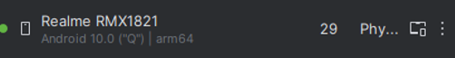 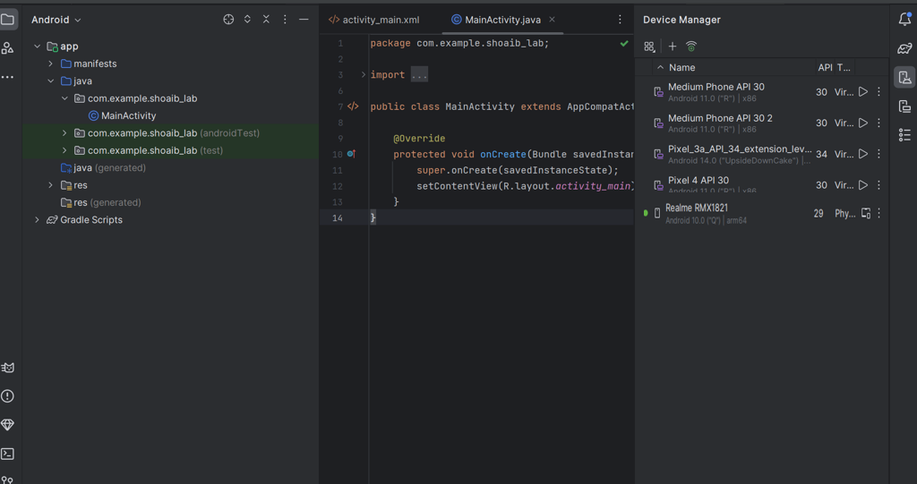

**Task No 02:** Install the Birthday Card Application in your Mobile devices using Android Debug Bridge.

**Solution:**

activity_main.xml:

<?xml version="1.0" encoding="utf-8"?>

<androidx.constraintlayout.widget.ConstraintLayout xmlns:android="http://schemas.android.com/apk/res/android"

    xmlns:app="http://schemas.android.com/apk/res-auto"

    xmlns:tools="http://schemas.android.com/tools"

    android:id="@+id/main"

    android:layout_width="match_parent"

    android:layout_height="match_parent"

    tools:context=".MainActivity">

    <ImageView

        android:id="@+id/imageView"

        android:layout_width="630dp"

        android:layout_height="1119dp"

        app:srcCompat="@drawable/birthday"

        tools:layout_editor_absoluteX="-124dp"

        tools:layout_editor_absoluteY="-259dp" />

</androidx.constraintlayout.widget.ConstraintLayout>

**Output:**

